EXPT NO: 10 | BUILDING A SIMPLE LLM CHATBOT USING STREAMLIT/GRADIO
DATE: 12.10.26 | BUILDING A SIMPLE LLM CHATBOT USING STREAMLIT/GRADIO

PRE-LAB QUESTIONS (PROVIDE BRIEF ANSWERS TO THE FOLLOWING QUESTIONS)

1. What is a Large Language Model (LLM)?
An LLM is an AI model trained on large amounts of text to understand and generate human-like language.

2. What is the role of the Transformer architecture in modern LLMs?
The Transformer uses an attention mechanism to understand relationships between words and generate meaningful text efficiently.

3. What is a prompt, and how does it influence an LLM's response?
A prompt is the input or instruction given to an LLM. It guides the model to generate a relevant response.

4. What is the difference between a chatbot and a conventional rule-based program?
A chatbot uses AI to understand user messages and generate responses, whereas a rule-based program follows predefined rules and conditions.

5. What are Stream lit and Gradio used for?
Stream lit and Gradio are Python libraries used to create interactive web interfaces for AI applications and chatbots.

AIM
To build a simple chatbot or AI application using a Transformer-based Large Language Model (LLM), process user prompts, generate responses, and deploy the application using Streamlit or Gradio.

SOFTWARE REQUIREMENTS
- Python
- Google Colab / Jupyter Notebook / Local Python environment
- Hugging Face Transformers
- PyTorch (or another supported model backend)
- Streamlit or Gradio
- GitHub (for version control and submission)
- A web browser
- An LLM API key, if using a hosted model API

OBJECTIVES
Students will be able to:
- Understand the basic working of Transformer-based LLMs.
- Select and load a suitable pretrained language model or connect to a hosted LLM API.
- Accept user input through a prompt-based interface.
- Generate and display responses from the selected model.
- Build a simple chatbot interface using Streamlit or Gradio.
- Maintain conversation history where supported.
- Test the chatbot with different prompts and evaluate the relevance of its responses.
- Run and demonstrate the deployed application.

PROCEDURE
PART A: ENVIRONMENT SETUP AND MODEL SELECTION
Perform the following tasks:
- Create a Python notebook or project folder.
- Install the required libraries, such as transformers, torch, and either Streamlit or Gradio.
- Choose a suitable pretrained instruction-following or conversational model or select a hosted LLM API.
- Read the model documentation and check its hardware, memory, access, and usage requirements.
- Load the model and tokenizer or configure the API client and store the API key securely as an environment variable.
- Test the setup with one simple input prompt.
(CODE: CONATAINS STUDENT ROLL NOS
SCREENSHOT OF CODE
SCREENSHOT OF OUTPUT)
PART B: PROMPT HANDLING AND RESPONSE GENERATION
Perform the following tasks:
- Define a function that accepts a user message as input.
- Prepare the prompt in the format required by the selected model or API.
- Pass the prompt to the model and generate a response using suitable generation settings.
- Decode and display the generated response clearly.
- Handle empty input and basic runtime or API errors.
- Test the function using at least five different prompts and record the responses.
(CODE: CONATAINS STUDENT ROLL NOS
SCREENSHOT OF CODE
SCREENSHOT OF OUTPUT)

PART C: BUILDING THE CHATBOT INTERFACE
Perform the following tasks:
- Choose either Streamlit or Gradio to create the user interface.
- Add a text box or chat input for entering user messages.
- Display the user message and the model-generated response in the interface.
- Maintain conversation history if supported by the selected model and interface.
- Add a clear-chat or reset option if appropriate.
- Run the application locally and test the interaction from a web browser.
(CODE: CONATAINS STUDENT ROLL NOS
SCREENSHOT OF CODE
SCREENSHOT OF OUTPUT)

PART D: TESTING AND DEPLOYMENT
Perform the following tasks:
- Test the chatbot with factual, conversational, and task-oriented prompts.
- Check whether the responses are relevant, readable, and consistent with the prompts.
- Identify any incorrect, biased, or unsafe responses and note the limitations.
- Deploy the application using an available hosting option supported by Streamlit or Gradio or demonstrate it locally if deployment access is unavailable.
- Do not upload API keys or other secrets to GitHub; use environment variables or the hosting platform's secrets settings.
- Save the source code, requirements file, screenshots of the interface, and sample outputs.
- Include the GitHub repository link and the application link, if publicly deployed, in the submission.
(CODE: CONATAINS STUDENT ROLL NOS
SCREENSHOT OF CODE
SCREENSHOT OF OUTPUT)

EXPECTED OUTCOME
Students will understand the basic use of Transformer-based LLMs for prompt-based text generation and chatbot development. They will build a working chatbot interface using Streamlit or Gradio, test its responses with different prompts, and run or deploy the application. Students will also identify limitations such as inaccurate responses, model-access requirements, latency, and responsible handling of user inputs and API credentials.
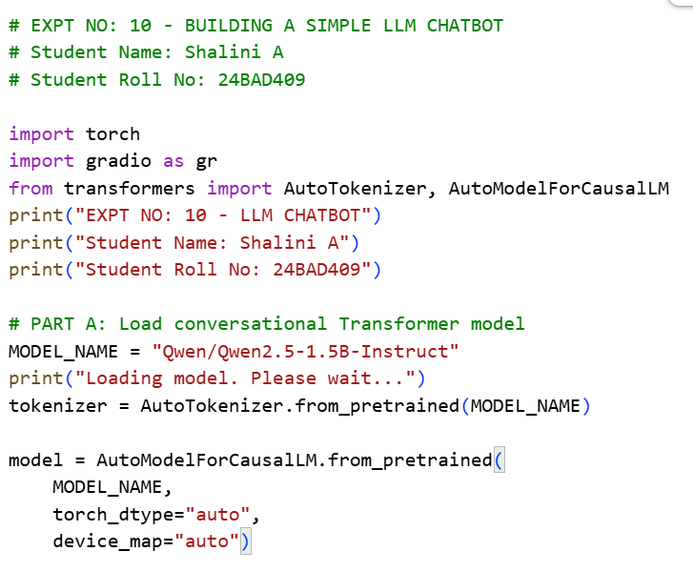
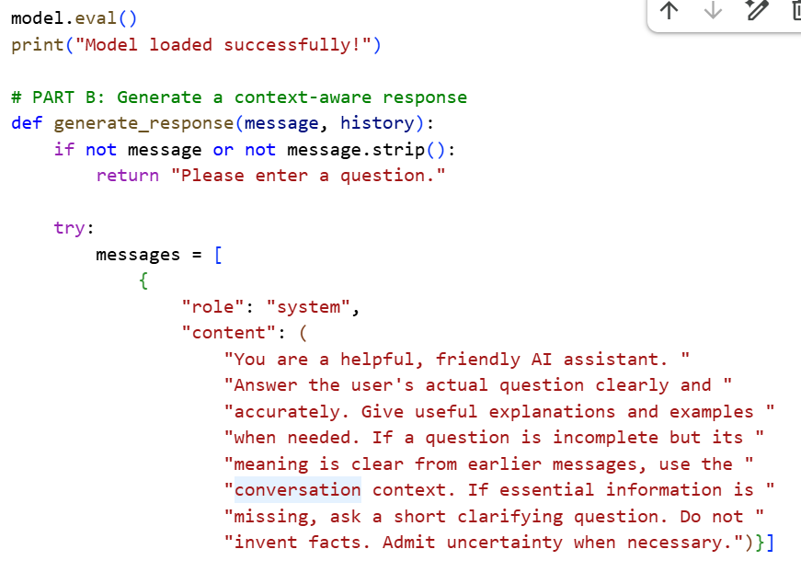

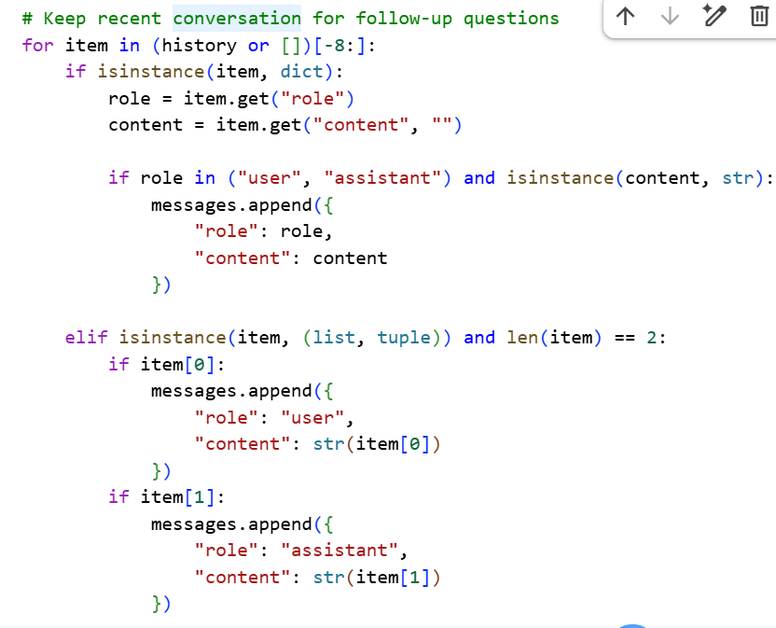
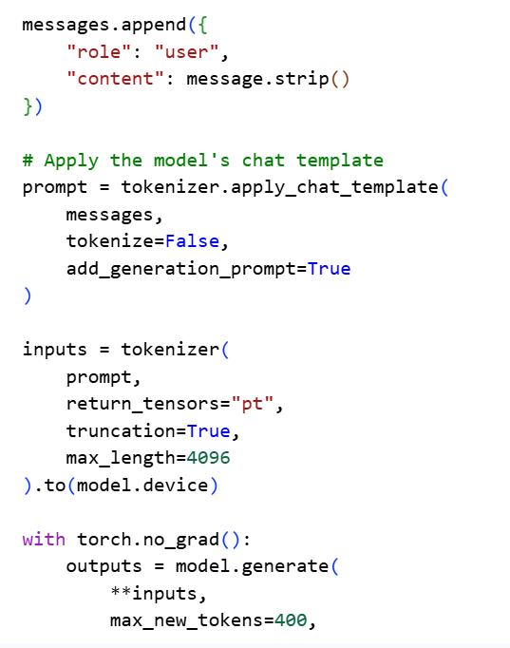
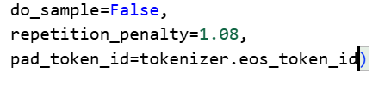
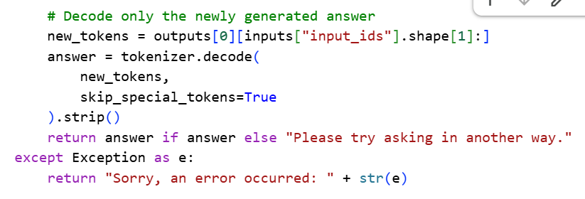

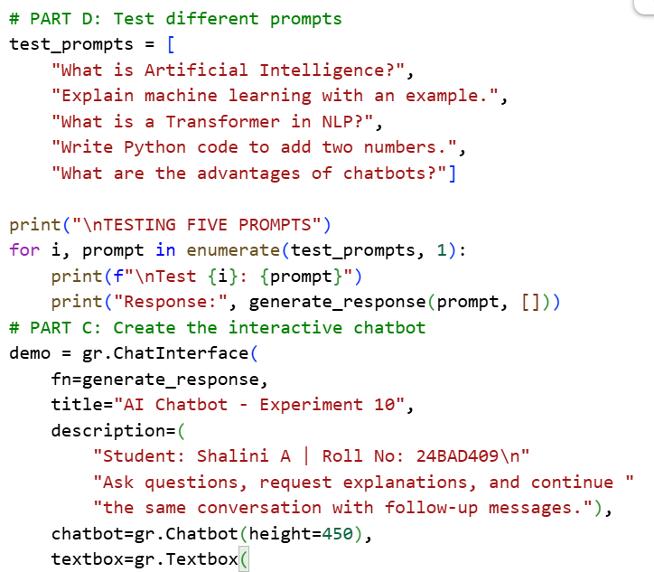
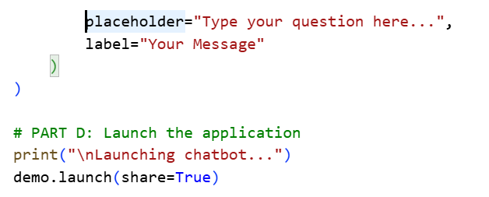
Output:
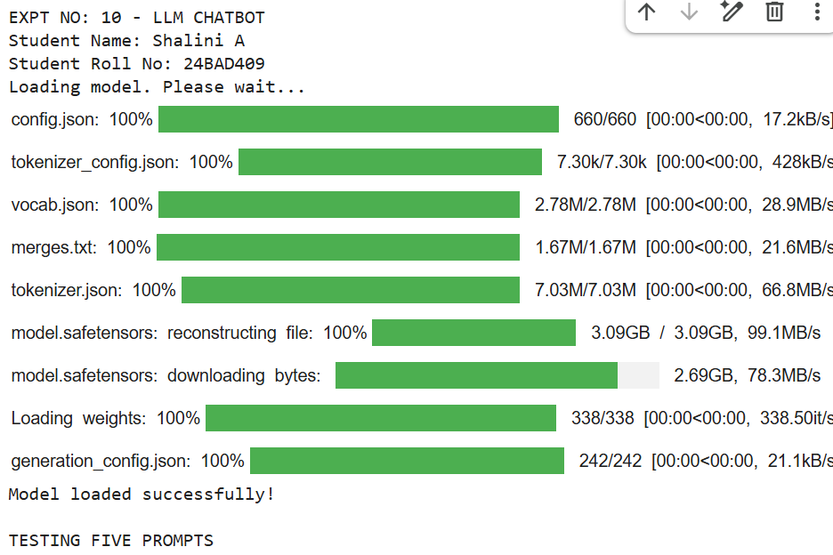
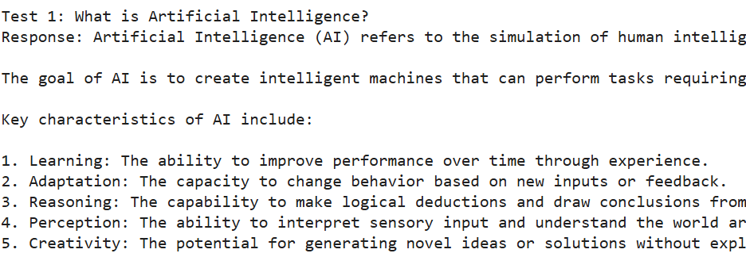

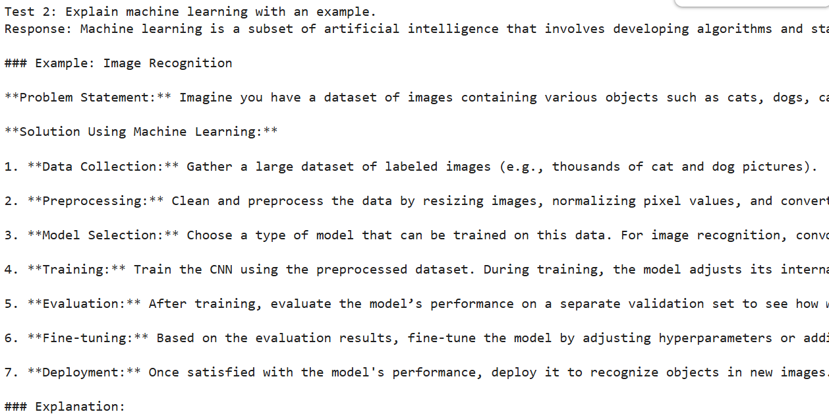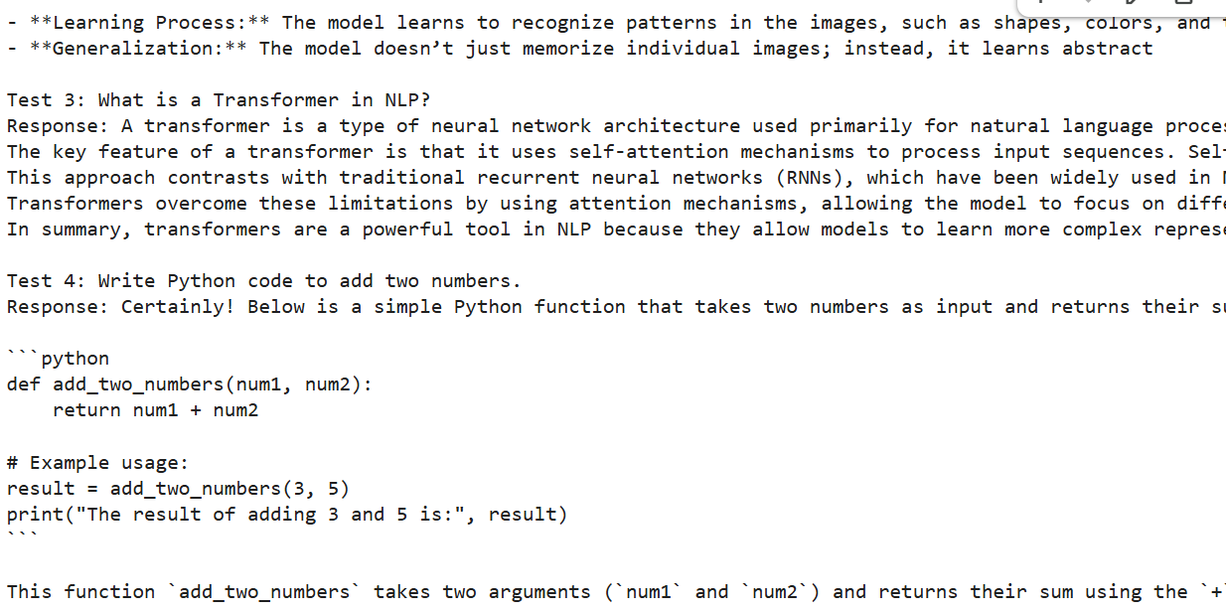
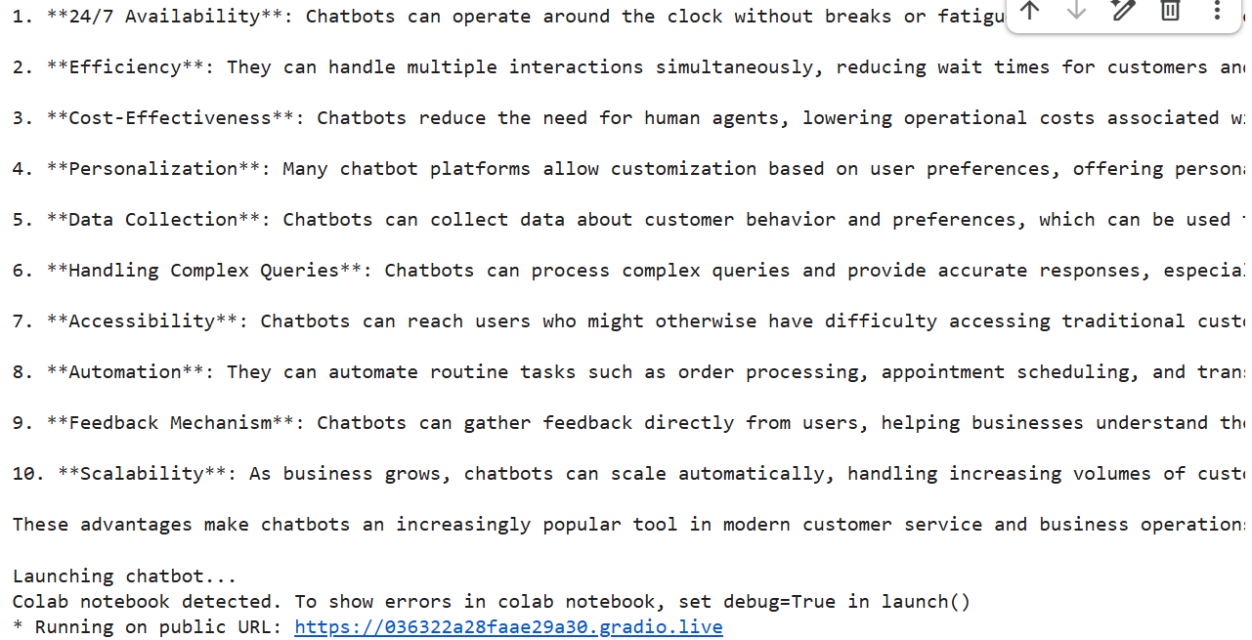

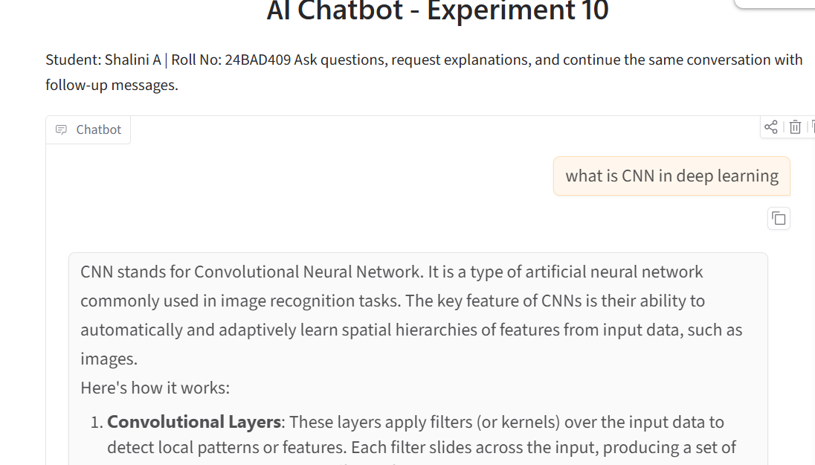
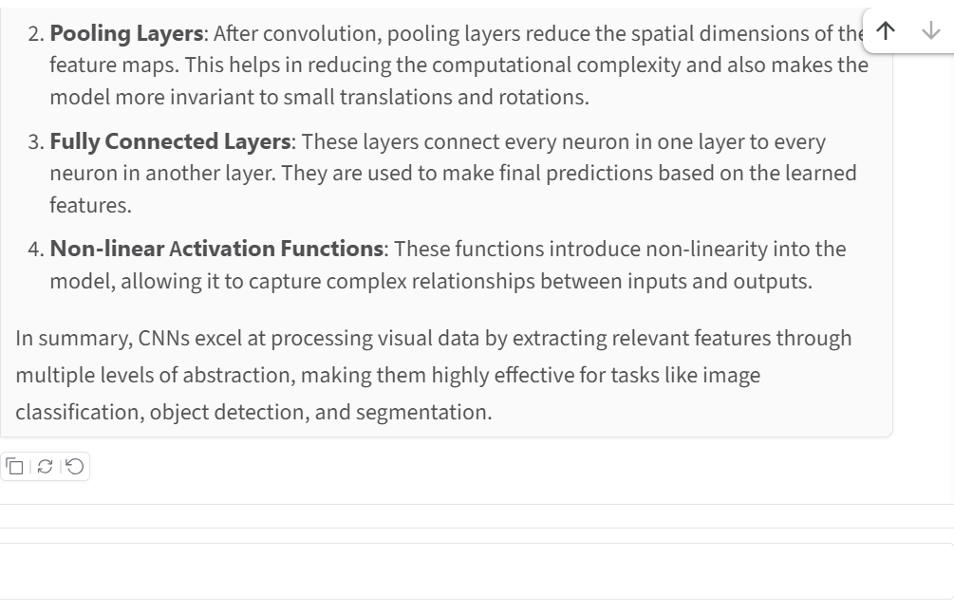

POST-LAB QUESTIONS (PROVIDE BRIEF ANSWERS TO THE FOLLOWING QUESTIONS)

1. What is the function of a tokenizer in an LLM application?
A tokenizer converts text into smaller units called tokens that the model can process.

2. How does a Transformer-based LLM generate a response to a prompt?
It processes the input tokens using attention mechanisms and predicts output tokens to generate a response.

3. What is the purpose of Stream lit or Gradio in this experiment?
They provide a user-friendly web interface to enter prompts and display chatbot responses.

4. Why should an API key be stored securely and not committed to GitHub?
An API key provides access to a service. Exposing it may allow unauthorized users to misuse the account or consume resources.

5. What is conversation history, and how can it improve a chatbot?
Conversation history stores previous messages. It helps the chatbot maintain context and provide more relevant responses.

6. Mention two limitations of LLM-based chatbots.
- They may generate incorrect or misleading answers.
- They may require significant computing resources or internet access.

7. How can you test whether a chatbot's responses are relevant?
Give it different prompts and check whether the answers are accurate, clear, and related to the questions.

8. What is the difference between running an application locally and deploying it online?
Running locally means the application operates on your own computer. Deploying online makes it accessible through the internet using a hosting service.

SUGGESTIONS FOR DATASETS
- Hugging Face Transformers documentation – https://huggingface.co/docs/transformers/index
- Hugging Face conversational / text-generation models – https://huggingface.co/models?pipeline_tag=text-generation
- Streamlit documentation – https://docs.streamlit.io/
- Gradio documentation – https://www.gradio.app/docs

ASSESSMENT
Description | Max Marks | Marks Awarded
Pre Lab Exercise | 5
In Lab Exercise | 10
Post Lab Exercise | 5
Viva | 10
Total | 30
Faculty Signature

